Tutorial 5: EtherChannel

- Explain EtherChannel with an aid of a diagram. Include TWO (2) benefits in setting up EtherChannel.

- EtherChannel interface can ensure the consistency of configuration throughout the links via grouping multiple individual ports together.
- EtherChannel does not require upgrading the link to a fast and more expensive connection to have more bandwidth.
- 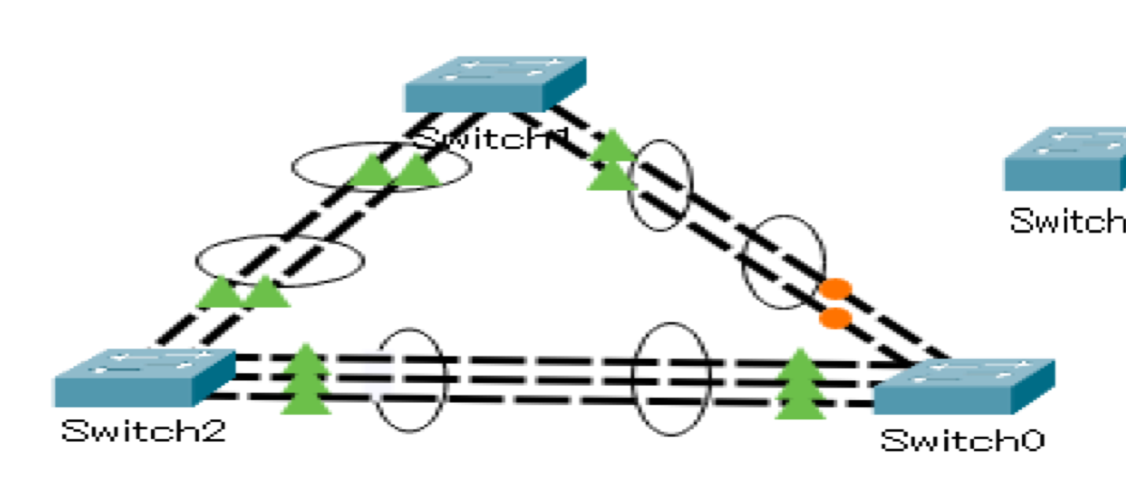
- enhance bandwidth
- enhance redundancy

- EtherChannels can be formed through negotiation using one of two protocols, Port Aggregation Protocol (PAgP) or Link Aggregation Control Protocol (LACP). These protocols allow ports with similar characteristics to form a channel through dynamic negotiation with adjoining switches. Fill in Table 5.1 to show the differences between PAgP and LACP.

 | PAgP | LACP
Compatibility | Only compatible with the same PAgP protocol. (Cisco device) | Only compatible with the same LACP protocol. (multivendor)
Modes of Negotiation  (Active Negotiation/Passive Negotiation) | - On: forces the interface to channel without PAgP. Interfaces configured in the on mode do not exchange PAgP packets. (X, not negotiation)  - PAgP desirable: Places an interface in an active negotiating state in which the interface initiates negotiations with other interfaces by sending PAgP packets.  - PAgP auto: Places an interface in a passive negotiating state in which the interface responds to be PAgP packets that it receives but does not initiate PAgP negotiation. | - On: Forces the interface to channel without LACP. Interfaces configured in the on mode do not exchange LACP packets. (X, not negotiation)  - LACP active: Places a port in an active negotiating state. In this state, the port initiates negotiations with other ports by sending LACP packets.  - LACP passive: Places a port in a passive negotiating state, the port responds to the LACP packets that it receives but does not initiate LACP packet negotiation.
Table 5.1 Differences between PAgP and LACP

- Based on Q2, explain both LACP modes of negotiation.

- LACP active
  - Places a port in an active negotiating state. In this state, the port initiates negotiations with other ports by sending LACP packets.
- LACP passive
  - Places a port in a passive negotiating state, the port responds to the LACP packets that it receives but does not initiate LACP packet negotiation.

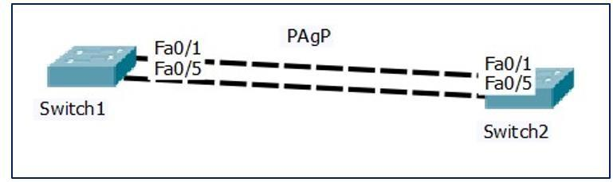
- Refer to Figure 5.2 and Figure 5.3, illustrate why PAgP EtherChannel is not created.
Figure 5.2: PAgP EtherChannel

Switch1#show run
:
<omitted ouput>
:
interface FastEthernet0/1
channel-group 3 mode auto

interface FastEthernet0/5
channel-group 3 mode auto

Switch2#show run
:
<omitted ouput>
:

interface FastEthernet0/1
channel-group 3 mode auto
interface FastEthernet0/5
channel-group 3 mode auto
Figure 5.3: “show run” command

- The interfaces are not configured as a trunk interface with the VLANs specified.
- All the port-channel interfaces on both Switch1 and Switch2 are set to auto, thus the PAgP EtherChannel would not be created.

- An EtherChannel was configured between switches S1 and S2, but the interfaces do not form an EtherChannel. Based on Figure 5.4, identify and rectify the problem. Justify your answers.

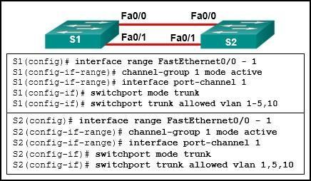
Figure 5.4 Configuration for S1 and S2 switches

- The VLAN allowed for both switches S1 and S2 should be the same so that the EtherChannel can be formed properly.
- In the figure, S1 switch has set VLAN 1, 2, 3, 4, 5 and 10 as allowed VLAN but S2 switch has set VLAN 1, 5, 10 as allowed VLAN only.

- Based on Figure 5.5 and the information as shown below, answer the following questions: Note:
  - All links in between switches are trunk links. Use permanent trunking mode.
  - Both Switch-1 and Switch-2 actively negotiate using PAgP to form an EtherChannel link.
  - Both Switch-2 and Switch-3 actively negotiate using LACP to form an EtherChannel link.

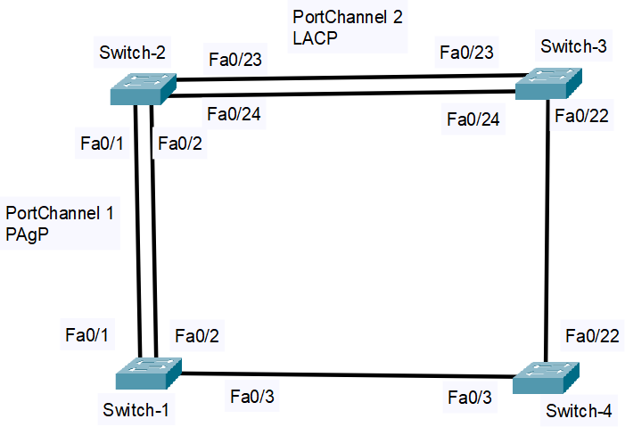

Figure 5.5: PAgP and LACP EtherChannels

- List the commands used to configure PAgP and LACP EtherChannels by using the Table 5.2.

Device | Configuration
Switch-1 | int range Fa0/1-2  channel-group 1 mode desirable  switchport mode trunk
Switch-2 | int range Fa0/1-2  channel-group 1 mode desirable  switchport mode trunk  int range Fa0/23-24  channel-group 2 mode active  switchport mode trunk
Switch-3 | int range Fa0/23-24  channel-group 2 mode active  switchport mode trunk
Table 5.2: Configuration to set up PAgP and LACP EtherChannels

- Based on the output of “show spanning-tree” for Switch-1 (Figure 5.6), is the interface
Po1 participating as single link or two links in Spanning Tree? Explain.
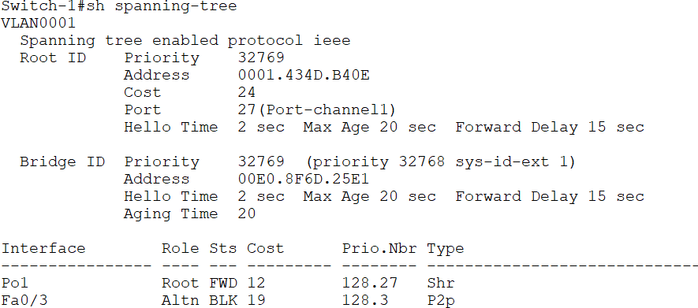

Figure 5.6: Output of “show spanning-tree” for Switch-1

- The interface Po1 is participating as single link in Spanning Tree.
- This is because the interfaces Fa0/1 and Fa0/2 have been grouped into a logical connection as port channel. So, Po1 will be treated as a single link.

